**Voltage Analysis 8/25 – Shane Irons**

**We definitely have an increase in numbers in production:**

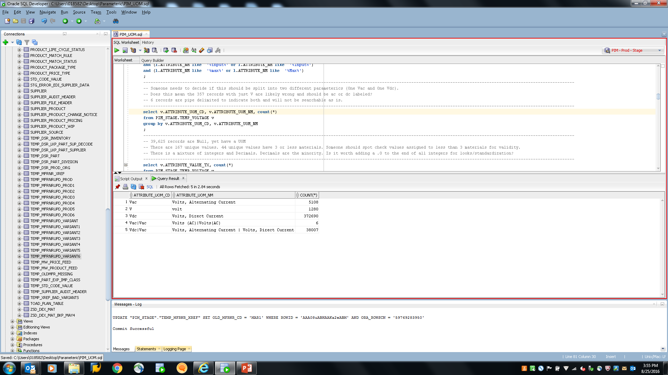

SQL:

select v.ATTRIBUTE_UOM_CD, count(*)

from PIM_STAGE.TEMP_VOLTAGE v

group by v.ATTRIBUTE_UOM_CD

;

**We still have some attributes with a | that do not have a matching UOM (1909 see Delimited Voltage.csv):**

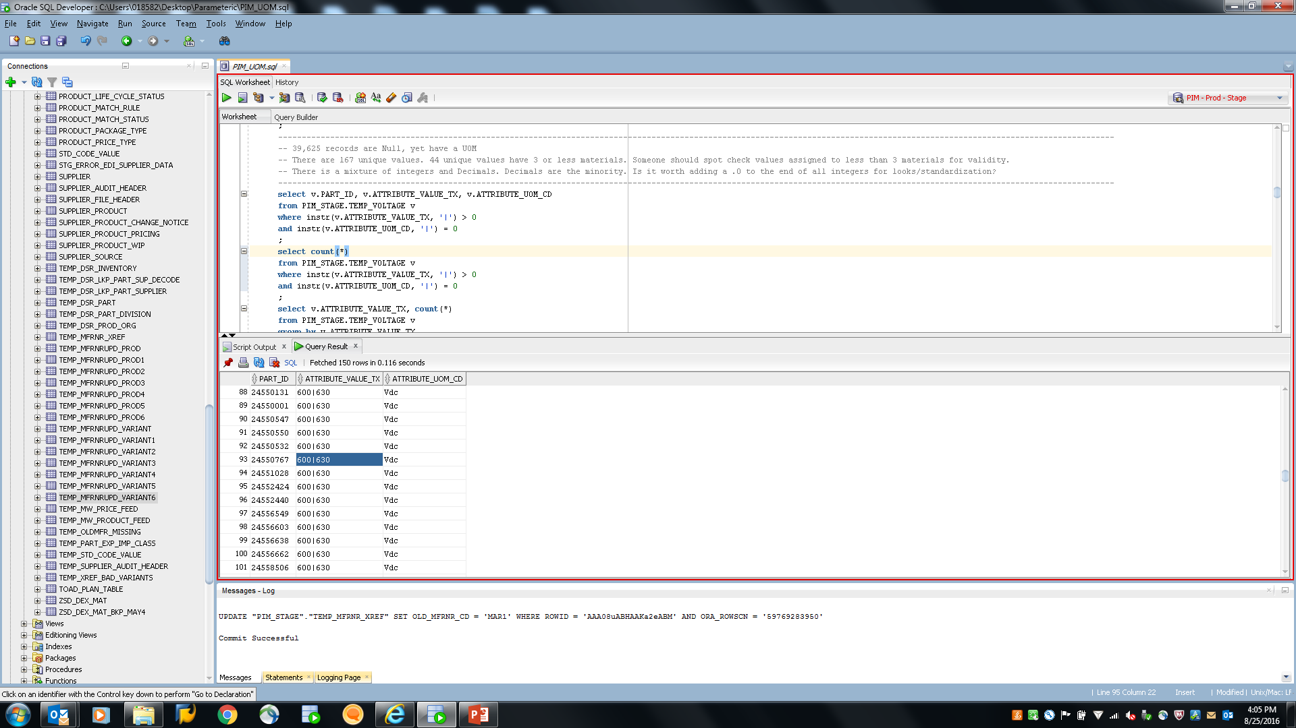

SQL:

select ar."ID" as VARIANT_AR_ID,

v.PART_ID as VARIANT_NO, v.ATTRIBUTE_VALUE_TX, v.ATTRIBUTE_UOM_CD, sgl."Name" as StructureGroupName

, ad."Res_Text100_01" as MFR_PART_NO--, ar2."ID" as VAIANT_AR_ID, ar2."Identifier" as VARIANT_NO, ar2."EntityID" as ENTITY_ID

, ad."Res_Text2G_02" as DATASHEET_URL

from PIM_STAGE.TEMP_VOLTAGE v,

hpm_master."ArticleStructureMap" asm,

HPM_MAIN."StructureGroupRevision" sgr,

HPM_MAIN."StructureGroupLang" sgl,

hpm_master."ArticleRevision" ar -- Variant

,hpm_master."ArticleRevision" ar2

,hpm_master."ArticleDetail" ad -- Manufacturer

where instr(v.ATTRIBUTE_VALUE_TX, '|') > 0

and instr(v.ATTRIBUTE_UOM_CD, '|') = 0

and instr(v.ATTRIBUTE_UOM_CD, '/') = 0

and v.ID = ar."ID"(+)

and v.ID = asm."ArticleRevisionID"(+)

and asm."StructureGroupID" = sgr."StructureGroupID"(+)

and sgr.ID = sgl."StructureGroupRevisionID"(+) and sgl."LanguageID"(+) = 9

and ar."ID"= ar2."ID"(+)

and ar2."ID" = ad."ArticleRevisionID"(+)

and ar2."EntityID"(+) = 1200

**The Vac|Vac parts actually have values now:**

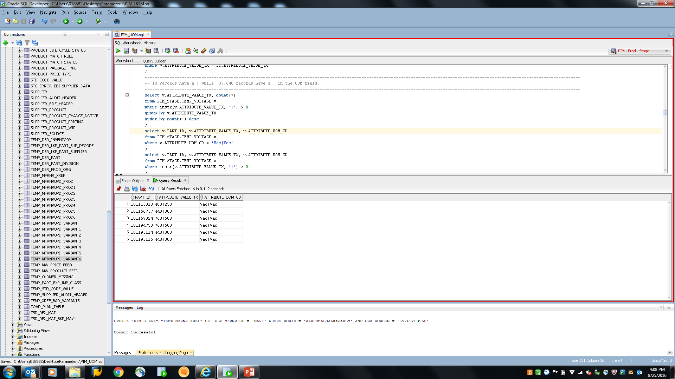

SQL:

select ar."ID" as VARIANT_AR_ID,

v.PART_ID as VARIANT_NO, v.ATTRIBUTE_VALUE_TX, v.ATTRIBUTE_UOM_CD, sgl."Name" as StructureGroupName

, ad."Res_Text100_01" as MFR_PART_NO--, ar2."ID" as VAIANT_AR_ID, ar2."Identifier" as VARIANT_NO, ar2."EntityID" as ENTITY_ID

, ad."Res_Text2G_02" as DATASHEET_URL

from PIM_STAGE.TEMP_VOLTAGE v,

hpm_master."ArticleStructureMap" asm,

HPM_MAIN."StructureGroupRevision" sgr,

HPM_MAIN."StructureGroupLang" sgl,

hpm_master."ArticleRevision" ar -- Variant

,hpm_master."ArticleRevision" ar2

,hpm_master."ArticleDetail" ad -- Manufacturer

where v.ATTRIBUTE_UOM_CD = 'Vac|Vac'

and v.ID = ar."ID"(+)

and v.ID = asm."ArticleRevisionID"(+)

and asm."StructureGroupID" = sgr."StructureGroupID"(+)

and sgr.ID = sgl."StructureGroupRevisionID"(+) and sgl."LanguageID"(+) = 9

and ar."ID"= ar2."ID"(+)

and ar2."ID" = ad."ArticleRevisionID"(+)

and ar2."EntityID"(+) = 1200

;

**1718 records with NULL Value, yet still have UOM:**

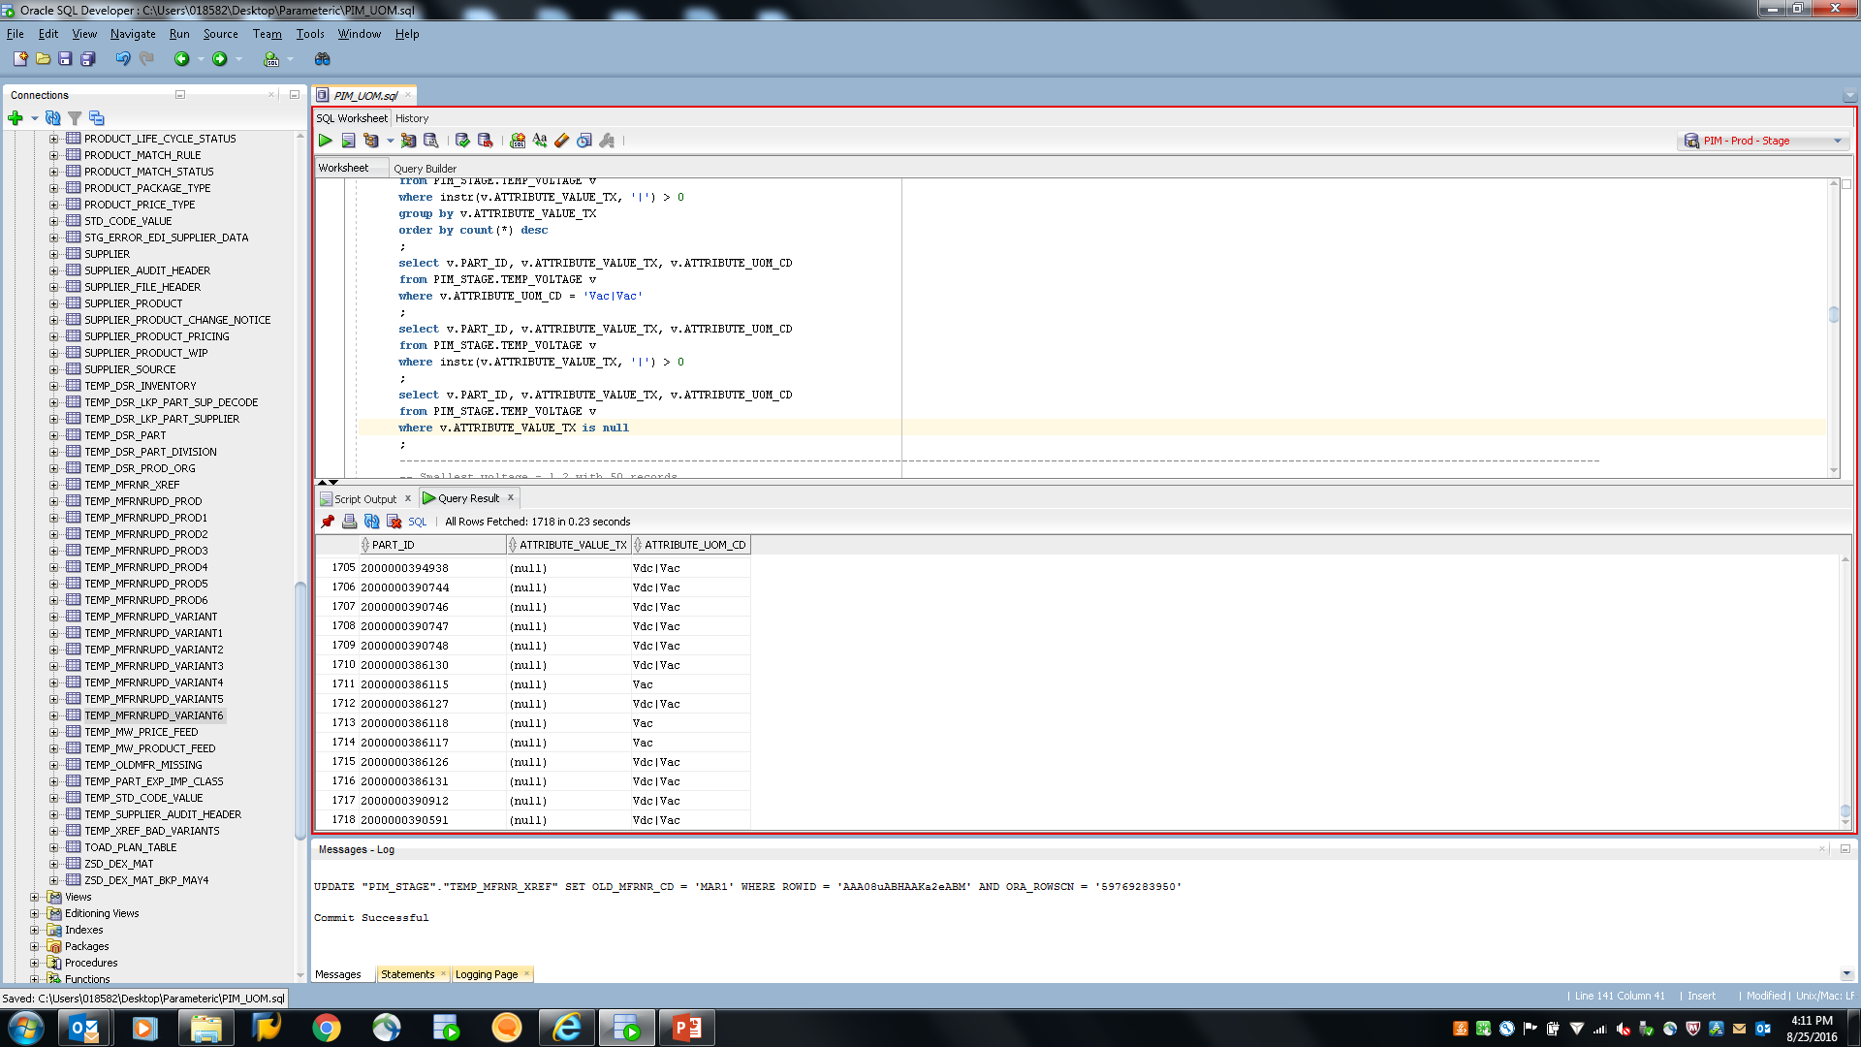

SQL:

select ar."ID" as VARIANT_AR_ID,

v.PART_ID as VARIANT_NO, v.ATTRIBUTE_VALUE_TX, v.ATTRIBUTE_UOM_CD, sgl."Name" as StructureGroupName

, ad."Res_Text100_01" as MFR_PART_NO--, ar2."ID" as VAIANT_AR_ID, ar2."Identifier" as VARIANT_NO, ar2."EntityID" as ENTITY_ID

, ad."Res_Text2G_02" as DATASHEET_URL

from PIM_STAGE.TEMP_VOLTAGE v,

hpm_master."ArticleStructureMap" asm,

HPM_MAIN."StructureGroupRevision" sgr,

HPM_MAIN."StructureGroupLang" sgl,

hpm_master."ArticleRevision" ar -- Variant

,hpm_master."ArticleRevision" ar2

,hpm_master."ArticleDetail" ad -- Manufacturer

where v.ATTRIBUTE_VALUE_TX is null

and v.ID = ar."ID"(+)

and v.ID = asm."ArticleRevisionID"(+)

and asm."StructureGroupID" = sgr."StructureGroupID"(+)

and sgr.ID = sgl."StructureGroupRevisionID"(+) and sgl."LanguageID"(+) = 9

and ar."ID"= ar2."ID"(+)

and ar2."ID" = ad."ArticleRevisionID"(+)

and ar2."EntityID"(+) = 1200

;

**Checking for un-allowed characters finds two records:**

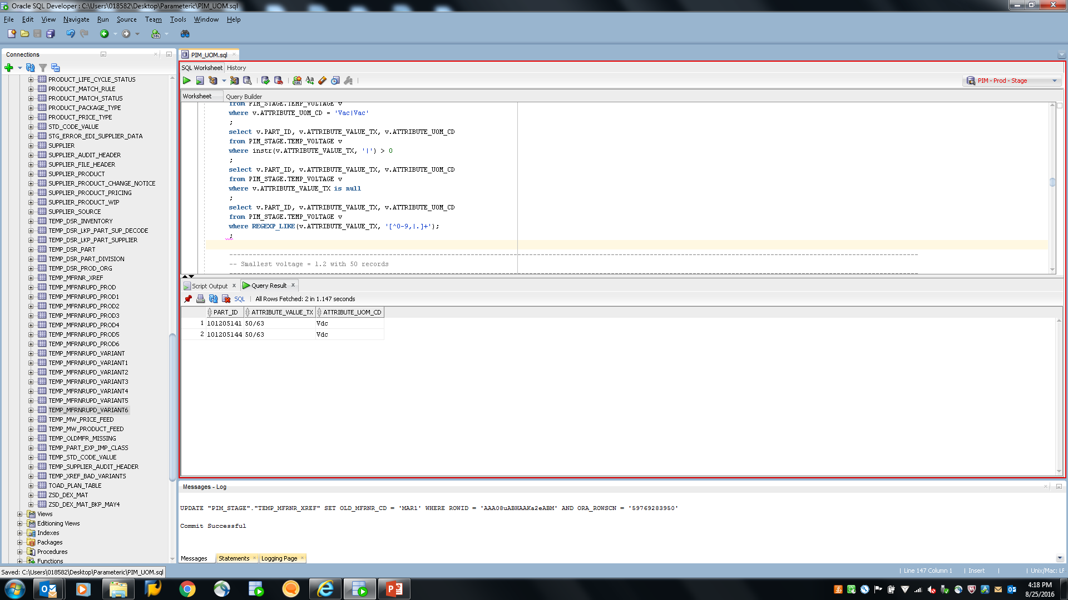

SQL:

select ar."ID" as VARIANT_AR_ID,

v.PART_ID as VARIANT_NO, v.ATTRIBUTE_VALUE_TX, v.ATTRIBUTE_UOM_CD, sgl."Name" as StructureGroupName

, ad."Res_Text100_01" as MFR_PART_NO--, ar2."ID" as VAIANT_AR_ID, ar2."Identifier" as VARIANT_NO, ar2."EntityID" as ENTITY_ID

, ad."Res_Text2G_02" as DATASHEET_URL

from PIM_STAGE.TEMP_VOLTAGE v,

hpm_master."ArticleStructureMap" asm,

HPM_MAIN."StructureGroupRevision" sgr,

HPM_MAIN."StructureGroupLang" sgl,

hpm_master."ArticleRevision" ar -- Variant

,hpm_master."ArticleRevision" ar2

,hpm_master."ArticleDetail" ad -- Manufacturer

where instr(v.ATTRIBUTE_VALUE_TX, '/') > 0

and v.ID = ar."ID"(+)

and v.ID = asm."ArticleRevisionID"(+)

and asm."StructureGroupID" = sgr."StructureGroupID"(+)

and sgr.ID = sgl."StructureGroupRevisionID"(+) and sgl."LanguageID"(+) = 9

and ar."ID"= ar2."ID"(+)

and ar2."ID" = ad."ArticleRevisionID"(+)

and ar2."EntityID"(+) = 1200;

**UOM Distribution still needs to be cleaned up:**

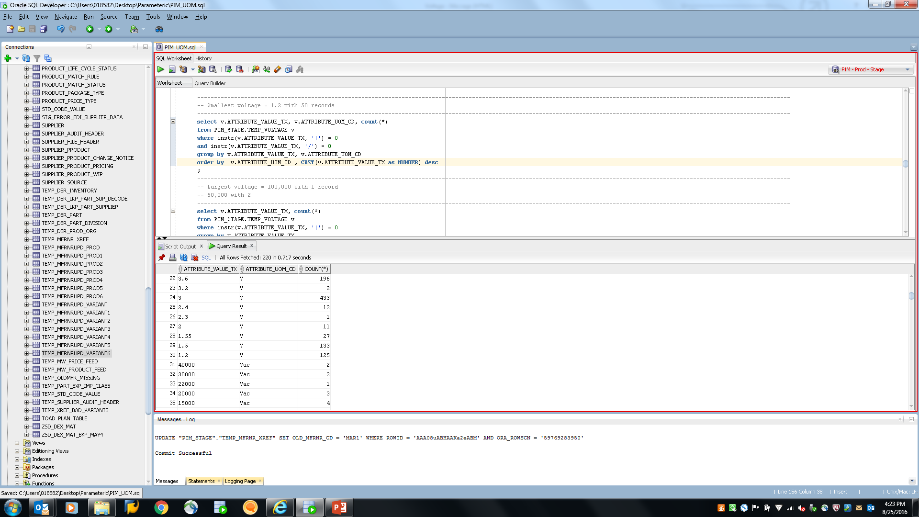

SQL:

select v.ATTRIBUTE_VALUE_TX, v.ATTRIBUTE_UOM_CD, count(*)

from PIM_STAGE.TEMP_VOLTAGE v

where instr(v.ATTRIBUTE_VALUE_TX, '|') = 0

and instr(v.ATTRIBUTE_VALUE_TX, '/') = 0

group by v.ATTRIBUTE_VALUE_TX, v.ATTRIBUTE_UOM_CD

order by v.ATTRIBUTE_UOM_CD , CAST(v.ATTRIBUTE_VALUE_TX as NUMBER) desc

;

**Hundredths in the decimal place:**

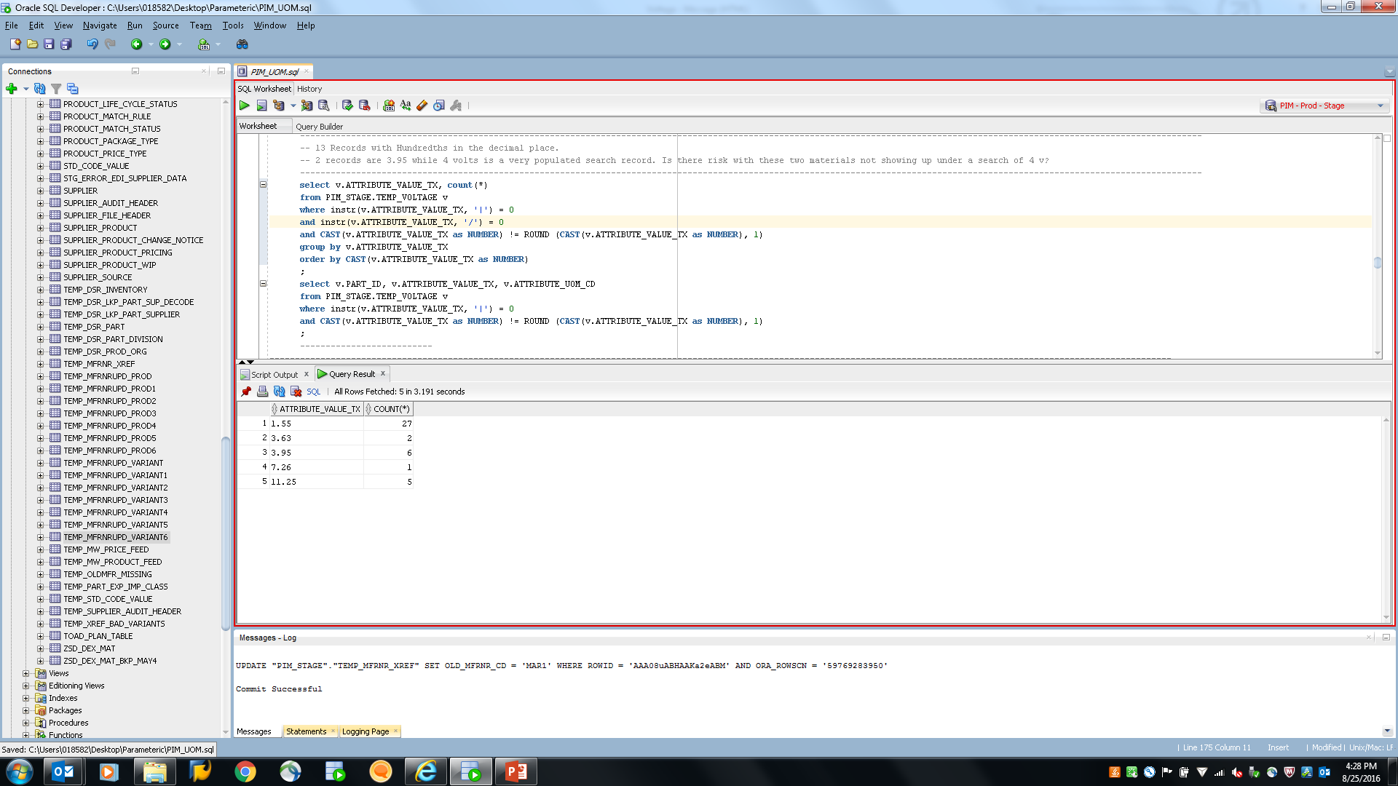

SQL:

select v.ATTRIBUTE_VALUE_TX, count(*)

from PIM_STAGE.TEMP_VOLTAGE v

where instr(v.ATTRIBUTE_VALUE_TX, '|') = 0

and instr(v.ATTRIBUTE_VALUE_TX, '/') = 0

and CAST(v.ATTRIBUTE_VALUE_TX as NUMBER) != ROUND (CAST(v.ATTRIBUTE_VALUE_TX as NUMBER), 1)

group by v.ATTRIBUTE_VALUE_TX

order by CAST(v.ATTRIBUTE_VALUE_TX as NUMBER) ;

The SQL for counts by taxonomy counts by UOM value

select sgl."Name" as StructureGroupName, v.ATTRIBUTE_UOM_CD, count(*)

from PIM_STAGE.TEMP_VOLTAGE v,

hpm_master."ArticleStructureMap" asm,

HPM_MAIN."StructureGroupRevision" sgr,

HPM_MAIN."StructureGroupLang" sgl,

hpm_master."ArticleRevision" ar -- Variant

,hpm_master."ArticleRevision" ar2

,hpm_master."ArticleDetail" ad -- Manufacturer

where v.ID = ar."ID"(+)

and v.ID = asm."ArticleRevisionID"(+)

and asm."StructureGroupID" = sgr."StructureGroupID"(+)

and sgr.ID = sgl."StructureGroupRevisionID"(+) and sgl."LanguageID"(+) = 9

and ar."ID"= ar2."ID"(+)

and ar2."ID" = ad."ArticleRevisionID"(+)

and ar2."EntityID"(+) = 1200

group by sgl."Name", v.ATTRIBUTE_UOM_CD

order by sgl."Name", v.ATTRIBUTE_UOM_CD

;

SQL for records displaying materials only assigned to voltage.

select sgl."Name" as StructureGroupName, count(*)

from PIM_STAGE.TEMP_VOLTAGE v,

hpm_master."ArticleStructureMap" asm,

HPM_MAIN."StructureGroupRevision" sgr,

HPM_MAIN."StructureGroupLang" sgl,

hpm_master."ArticleRevision" ar -- Variant

,hpm_master."ArticleRevision" ar2

,hpm_master."ArticleDetail" ad -- Manufacturer

where v.ATTRIBUTE_UOM_CD = 'V'

and v.ID = ar."ID"(+)

and v.ID = asm."ArticleRevisionID"(+)

and asm."StructureGroupID" = sgr."StructureGroupID"(+)

and sgr.ID = sgl."StructureGroupRevisionID"(+) and sgl."LanguageID"(+) = 9

and ar."ID"= ar2."ID"(+)

and ar2."ID" = ad."ArticleRevisionID"(+)

and ar2."EntityID"(+) = 1200

group by sgl."Name"

order by sgl."Name";